**What is Archetype?**

In short, Archetype is a Maven project templating toolkit. An archetype is defined as *an original pattern or model from which all other things of the same kind are made*. The name fits as we are trying to provide a system that provides a consistent means of generating Maven projects. Archetype will help authors create Maven project templates for users, and provides users with the means to generate parameterized versions of those project templates.

Using archetypes provides a great way to enable developers quickly in a way consistent with best practices employed by your project or organization.

Maven web project

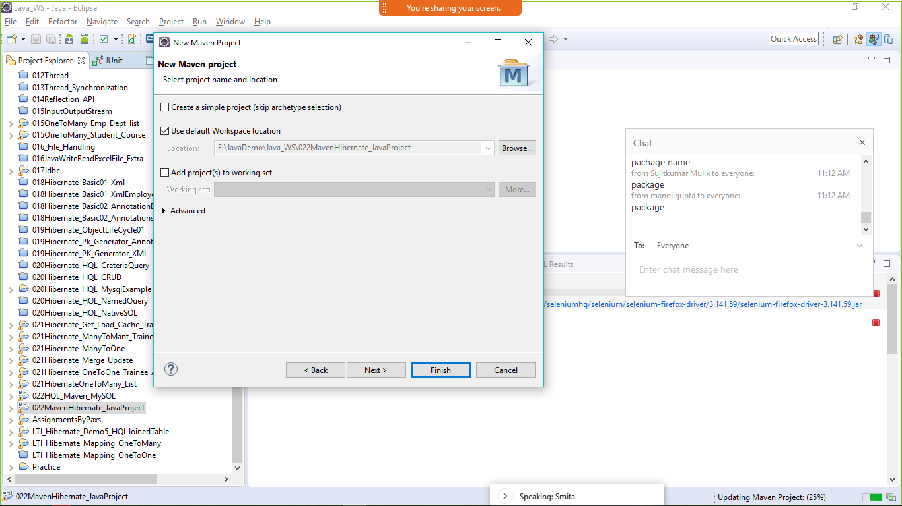4

Next

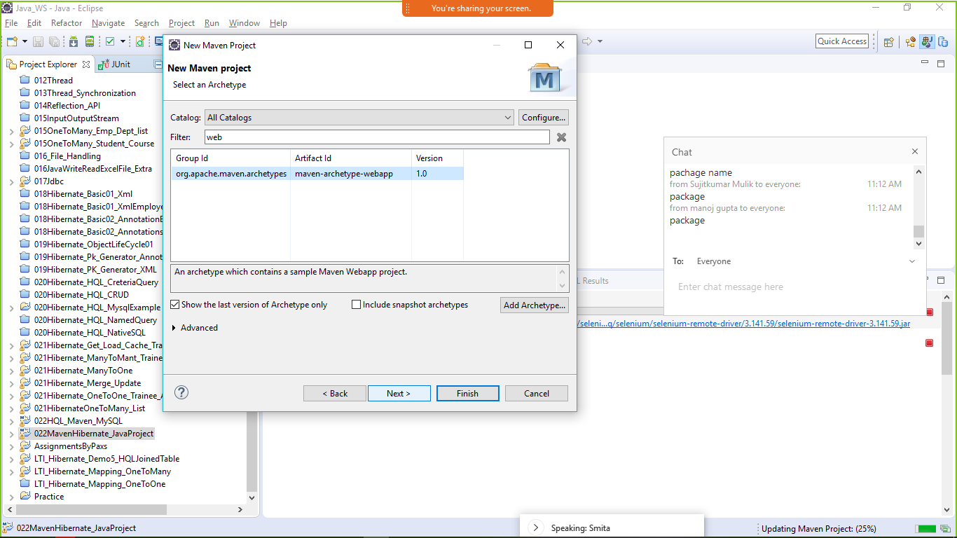

Enter web archetype

Next

Provide package name -group Id

Provide Project name- artefact id 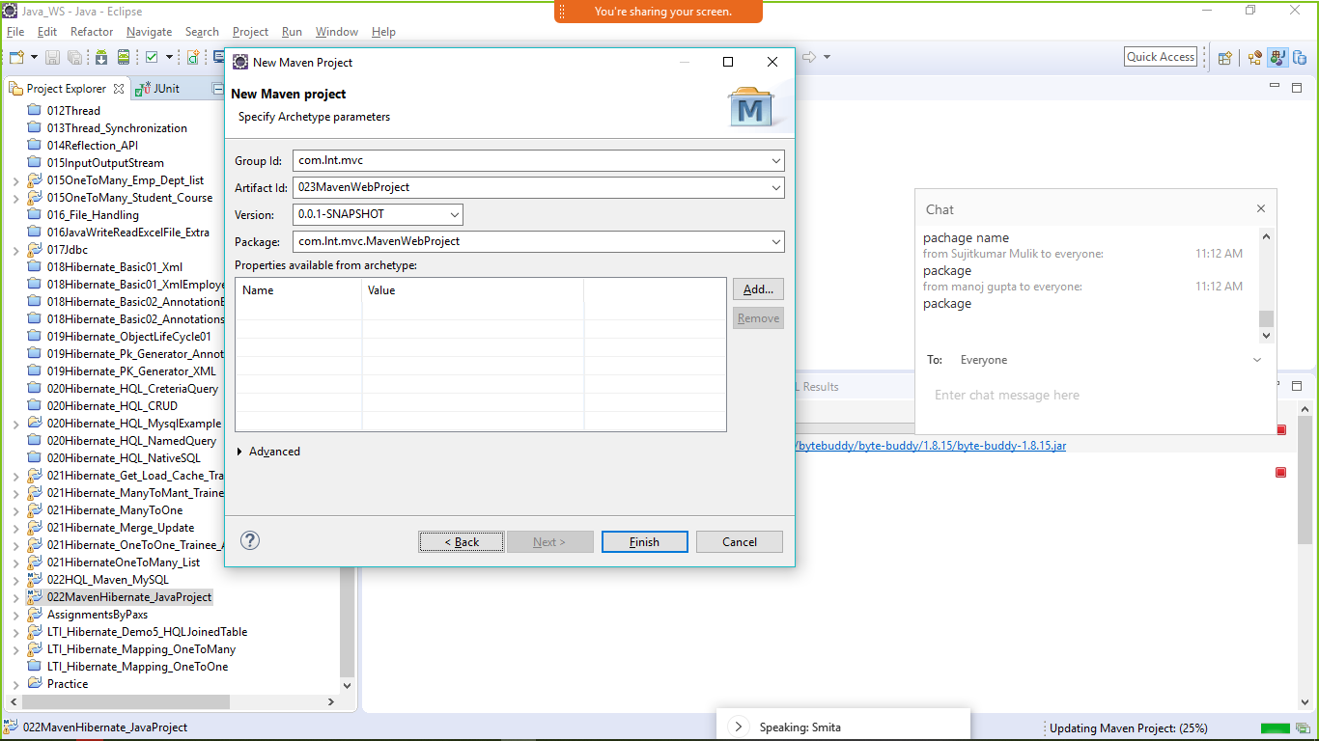

Finish

Maven web project stricture

